Game Theory for Rebels
A Guide for the Oppressed

Part II

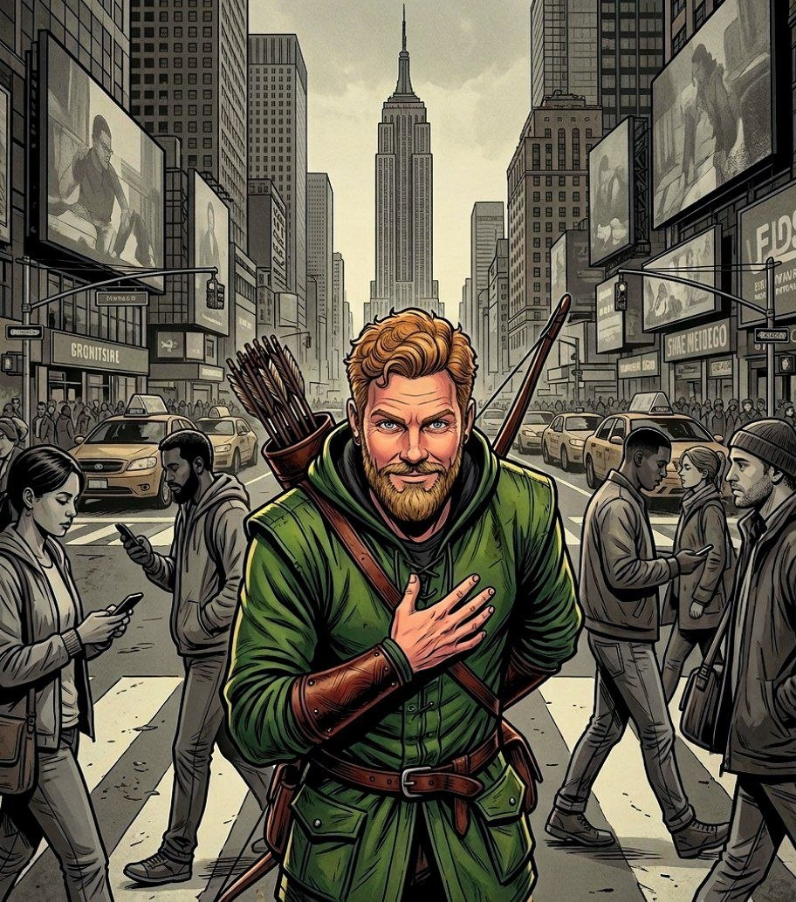

Ropes Pierre

Game Theory for Rebels
A Guide for the Oppressed

Part II

By Ropes Pierre

Published by:
The Swarm of Strategic Rebels
who Volunteer to share this document.
Copyright Notice (CC BY 4.0)

This work is released into the public domain under the Creative Commons Attribution Licence (CC BY 4.0). You are free to copy, distribute, and adapt this work, on condition that any derivative works or reproductions must properly name and credit the original source/author.

Since the author is anonymous, appropriate credit specifies where the author posts his philosophical work, more specifically https://thepragmaticrealist.substack.com/, and can be in several forms such as:

- "The Pragmatic Realist (Substack)", with or without hyperlink.
- "thepragmaticrealist.substack.com", with or without hyperlink.
- "Ropes Pierre", with hyperlink to Substack or the address displayed.
- "Ropes Pierre via The Pragmatic Realist (Substack)", with or without hyperlink.

Game Theory for Rebels 2:
Thinking Like a Game Theorist

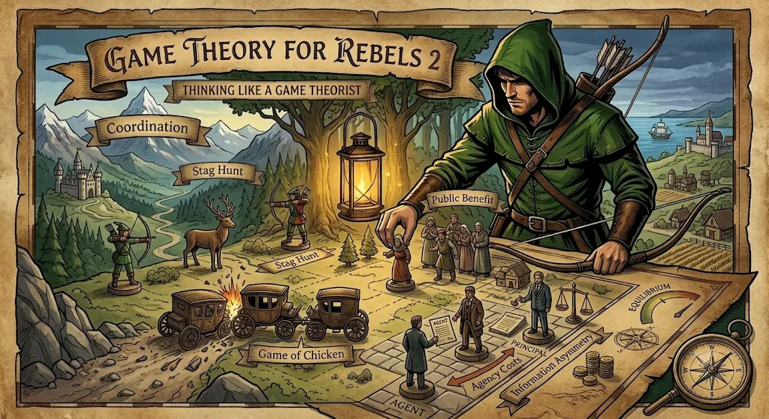
We previously established the Anatomy of the Game and considered some basic implications of the Nash Equilibrium. We demonstrated that any corrupted, highly extractive political system is inherently unstable because it cannot remain in a stable Nash Equilibrium.
This structural realism provides us with absolute mathematical assurance that the passive compliance of the Ruled cannot endure in the face of systemic oppression. Eventually, their Strategy must change to something that provides a better Pay-Off.
Before we can model the complex dynamics of social conflict between the Ruler and Ruled populations, exploit the vulnerabilities of aberrant autocrats, or execute sophisticated cost-imposition strategies, we must first learn how to think in terms of Game Theory.
We will be examining five foundational games that serve as the strategic blueprints of everyday social and political friction. They provide a foundational understanding of how trust is built, how threats are evaluated, how bystanders are paralysed, how agents are corrupted, and how information is controlled.
As a Rebel, you must learn to identify which of these games is being played on the board at any given moment. Crucially, you must also learn how to deliberately set up these situations in order to change the Environmental Pressures and Pay-Offs for an oppressive regime.

The Deterrence Game: Action and Inaction

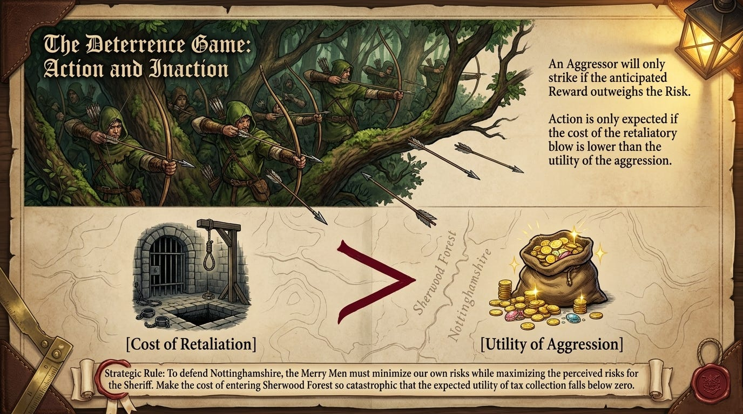
The simplest game that we will consider is the Deterrence Game. It was originally designed as the mathematical backbone for the Mutually Assured Destruction (MAD) doctrine of the United States and the Soviet Union during the Cold War.
The goal was to prevent a nuclear first strike by ensuring that the defending nation maintained a highly visible, automated, and survivable second-strike capability. This guaranteed that any act of Aggression would trigger an automatic Retaliation so catastrophic that the expected utility of the invasion would fall below zero.
In the Deterrence Game, the Aggressor will only refrain from initiating an attack if the cost of the retaliatory blow exceeds the anticipated Benefit of the Aggression:

Cost of Retaliation > Benefit of Aggression → No Action
The most reductionist form of Game Theory is the principle that action is only expected if the Risk is not larger than the Reward.
Both the Ruler and the Ruled populations have the ability to change the Risk and Reward matrices for either side. Since either side can escalate, the is no monopoly on violence. One side simply has a more credible threat than the other, but credibility can change over time.
An oppressive regime will try to make the risk of resistance seem to outweigh the potential reward.
An active citizenry should maximise the Risks associated with political over-reach and minimise the perceived Reward. This actually maximises the Perceived Value of society for both the Ruler and the Ruled populations, as we will prove later using Monte Carlo simulations.
On the other hand, to defend your movement you need to minimise your own Risks, while maximising the Reward anticipated with your Strategies.
In this regard, any good Strategy should have a combination of offensive and defensive elements.

The Game of Chicken: Brinkmanship and Swerving

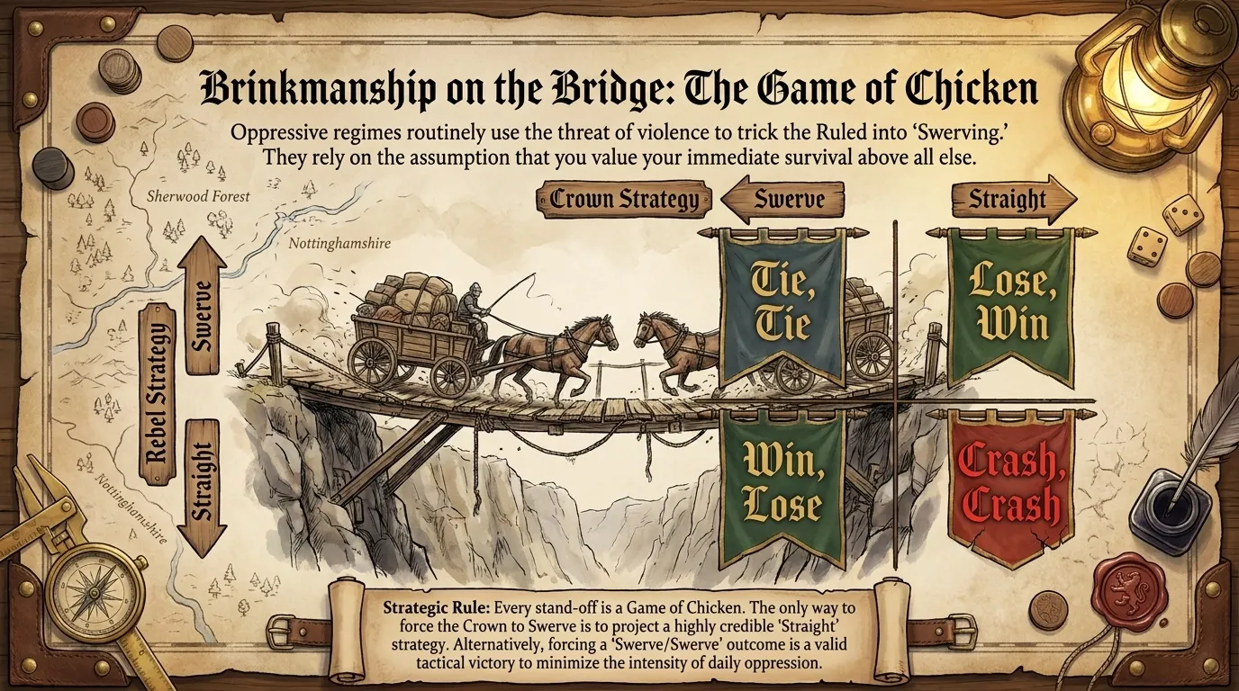
The Game of Chicken gets its name from the car-racing stunt popularised in James Dean’s Rebel Without a Cause, 1955.
In the real world, the original application of this game was Cold War crisis management, most notably during the 1962 Cuban Missile Crisis.
Both the United States and the Soviet Union drove towards the brink of thermonuclear war. Each superpower wanted the other to concede, or Swerve, first. If both head Straight, the joint outcome was mutual destruction.
This game is modelled by two players heading on a collision course, where the worst-case scenario occurs when both choose the Aggressive, non-cooperative Strategy.
Oppressive regimes routinely use the threat of physical and economic violence to trick the Ruled into Swerving. They rely on the assumption that the Ruled value their comfort or survival above all else.
Any resistance that the Ruled forms against an oppressive regime is challenging the authority of the Rulers, and so every stand off is essentially a Game of Chicken.
The only way to get the regime to Swerve is to threaten a Straight/Straight situation. However, a Swerve/Swerve outcome is also desirable if it minimises the intensity of the oppression.
In a Swerve/Swerve situation, both Players will try to get the other to Swerve harder, which amounts to a Game of Chicken within a Game of Chicken. An elegant rebellion must learn to make use of this, since outright confrontation is not the only move you can make during a battle.
The more credible the threat, the more likely your opponent will Swerve.

The Stag Hunt: Coordination and Defection

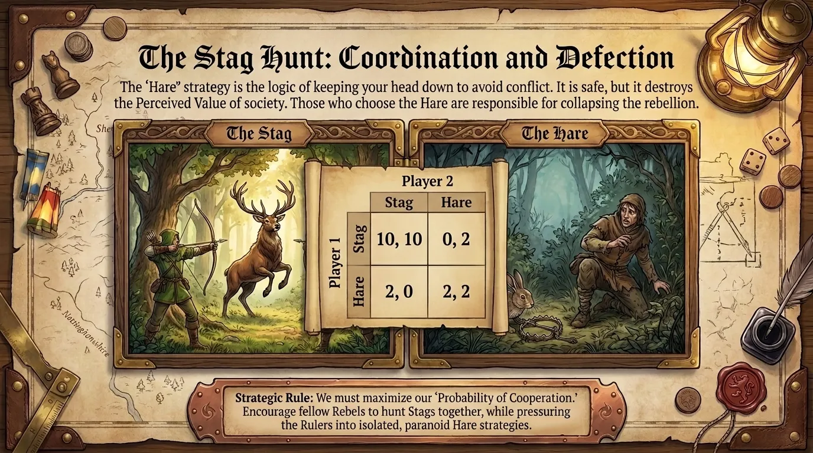
The Stag Hunt, also referred to as the Assurance Game, Trust Dilemma or Common Interest Game, was developed by Jean-Jacques Rousseau in his Discourse on Inequality, 1755.
Two hunters are needed to catch a high-value Stag. If they work together, they both succeed and get a high Pay-Off. However, if a low-value Hare passes by, one hunter might be tempted to defect to capture the Hare for immediate, guaranteed survival but with a small Pay-Off, leaving the other hunter with nothing.
Mathematically, the Stag Hunt is represented as a coordination matrix where mutual cooperation yields the highest collective Pay-Off, but defection is the safer, low-risk Strategy.
The Stag Hunt explains why sovereign nations struggle to cooperate on global challenges, such as mutual disarmament or climate treaties, even when cooperation yields the highest mutual benefit. It has also been adopted to model cooperation under anarchy by Kenneth Waltz.
The Stag Hunt explains the logic of keeping your head down and minding your own business: you are guaranteed to avoid conflict if you go for the easy way out.
However, it also proves that this mindset does tremendous damage to the Perceived Value of society, because you are giving up genuine gains in prosperity for the easy bread crumbs.
The people who choose the Hare strategy are responsible for collapsing any attempt by the Ruled to reverse the decline of society, but you do not need the entire population to hunt Stags successfully, just a minimum proportion.
In a multi-round game, we can talk of these strategies in terms of the Probability of Cooperation, which can be interpreted as the proportion of a population that adopts a Stag strategy.
A Rebel needs to encourage other Rebels to hunt Stags, while pressuring the oppressive Rulers into a situation where a few of them starts adopting a Hare strategy.
In terms of the Ruler vs the Ruled, it is in the interest of the Rulers to pressure the Ruled into a compliant Hare strategy, while it is in the interest of the prosperity of society for the Ruled to prefer a Stag strategy when pushing back against political overreach.

The Volunteer’s Dilemma: Action and Inaction

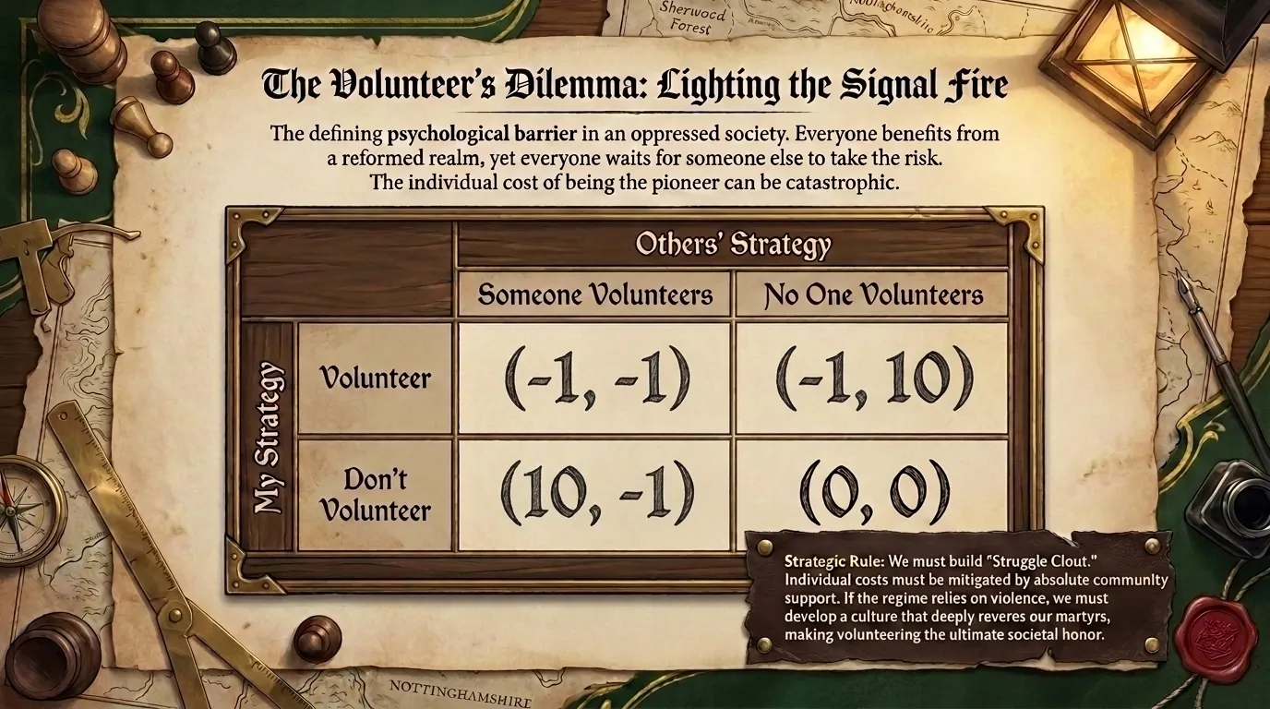
Kitty Genovese was murdered in her home in New York in 1964. Her neighbours heard her cries for help, but no one called the police. Each individual assumed that someone else would do it, or had already phoned the police. This phenomenon was called the Bystander Effect.
The Volunteer’s Dilemma was formalised in 1985 by sociologist Andreas Diekmann, inspired by the Bystander Effect.
It models any situation where a single player must bear a personal Cost to provide a public Benefit that is enjoyed by everyone, regardless of who Volunteered.
The Pay-Off structure shown in the diagram above is such that the group benefits from the sacrifices of the one, be this resources, effort or something else, and there is no benefit if no one does anything.
The original applications of the Volunteer’s Dilemma explain failures in public goods provision and crisis management. For example, an entire neighbourhood might sit in the dark during a power outage because every household waits for a neighbour to make the tedious phone call to the electricity provider.
If you live in an oppressive society, this game is the defining psychological barrier to change. The rational, short-term Strategy for every citizen is to wait for someone else to take the risk.
Everyone knows that something must be done to challenge the system, whether organising a strike, speaking out, or protesting, yet few people are willing to be the first person to put their neck on the line.
The individual Cost of being a pioneer can be catastrophic: arrest, professional ruin, or physical violence. On the other hand, everyone Benefits from a reformed society where the Rulers are no longer as oppressive and extractive towards the Ruled, including those who stayed safe.
Individual Costs can be mitigated by community support structures, while the perceived Benefits of Volunteering can be reinforced by a shared vision of what a better society looks like.
Historically, Resistance Movements have used a mechanism of struggle clout to enhance the perceived Benefit of Volunteering. If the oppressive regime resorts to murder, develop a culture of revering martyrs to the cause.

The Principal-Agent Problem: Information and Concealment

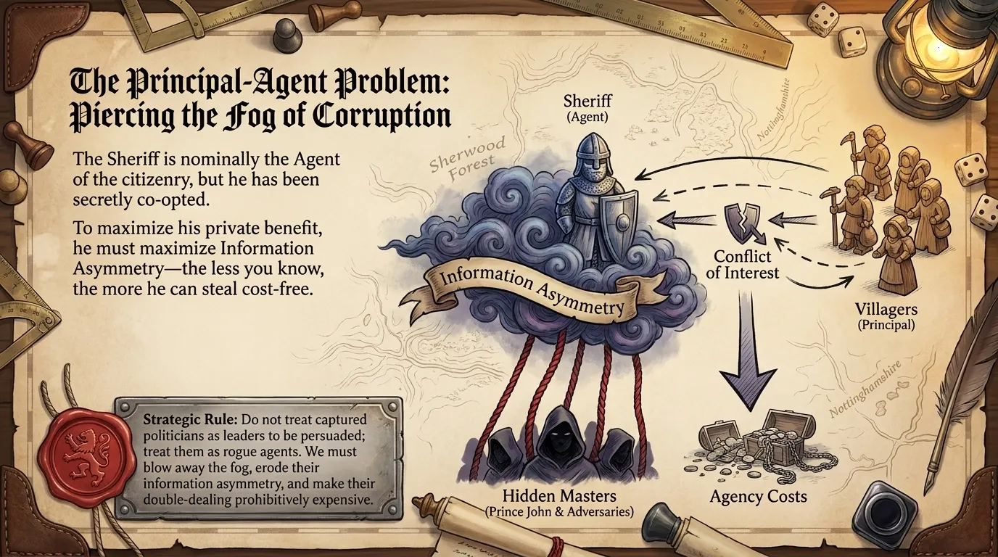
The Principal-Agent Problem emerged during the 1970s, pioneered by economists Stephen Ross, and Michael Jensen & William Meckling. It explores the structural friction, conflicts of interest, and inefficiencies that occur when one party, the Principal, delegates decision-making authority to another party, the Agent.
The consequences of a conflict of interests between a Principal and Agent is represented as follows:
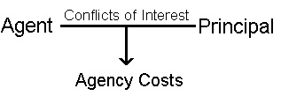

While traditionally applied to corporate governance, the most profound application of this model lies in representative democracy. The voting Ruled population acts as the Principal, delegating executive, legislative, and representative authority to the Rulers, who act as their Agents.
Voters charge these politicians with a strict mandate: to enact policies that maximise the collective utility of the citizenry and to deliver on campaign promises.
However, because of Information Asymmetry, the Agent can get away with enacting ulterior motives due to conflicts of interest, generating and Agency Cost that draws away from the Perceived Value of society.
In a corrupted system, this problem manifests as systemic capture, and the Agency Costs that society must suffer for each responsibility they give to the government inflates as a result.
The politician is nominally the Agent of the citizenry, but they have been secretly co-opted by corporate interest groups or foreign adversaries. These external entities offer private Benefits such as campaign donations, post-political board seats, or direct financial intelligence, that dwarf the perceived utility of public service.
The politician’s dominant Strategy shifts to serving these hidden masters. In order to maximise their own Benefit, the Rulers need to maximise Information Asymmetry. The less the voters know, the more they can get away with Cost-free.
Rebels must treat captured politicians not as leaders to be persuaded, but as rogue Agents whose Information Asymmetry needs to be eroded and whose double-dealing must be made prohibitively expensive.
Furthermore, it warns us to minimise delegation: each individual must do as much as he can by himself. This further highlights the necessity of a culture of Voluntarism:
It is better to ask for forgiveness
than to ask for permission!

A Note on Strategies

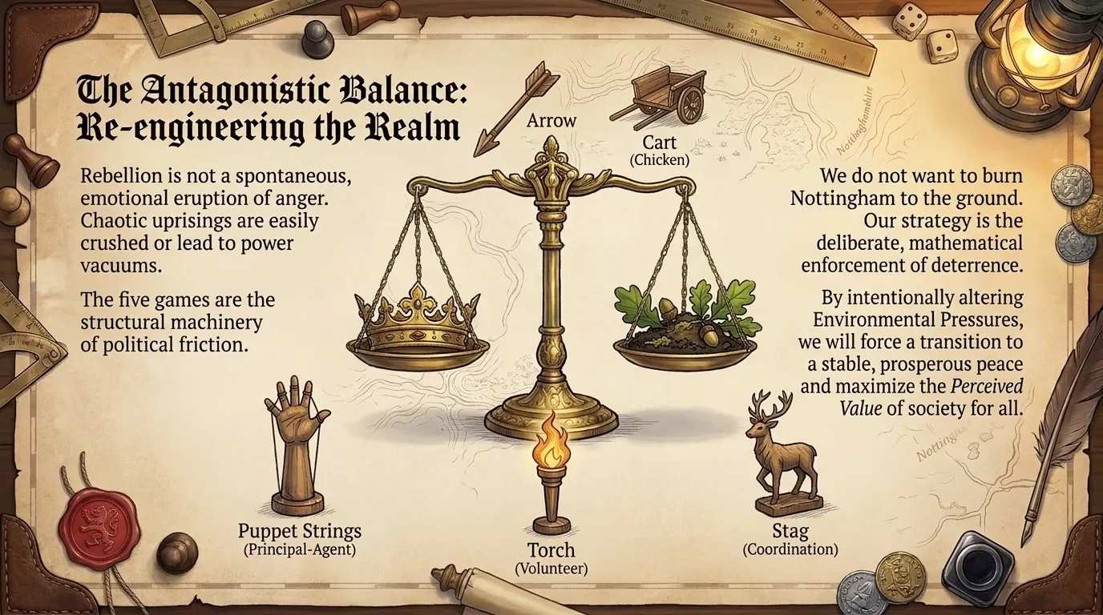
Rebellion is often romanticised as an emotional eruption of collective anger, but this is just a stereotype because there are other forms of rebellion.
History shows us that spontaneous, unstructured uprisings are highly volatile. They are easily hijacked, brutally crushed, or lead directly to chaotic power vacuums and systemic collapse.
The five games that we considered here are not academic abstractions, they are the underlying structural machinery of everyday political friction. We need to stop viewing oppression as an insurmountable moral evil and begin analysing it as a series of flawed, exploitative Pay-Offs that can be systematically re-engineered.
Our goal is not to burn down the board when seething anger reaches a boiling point. The goal of a coordinated Rebel population should be to understand these structural dynamics so deeply that we can intentionally alter the Environmental Pressures and change the nature of the game.
This is how we force a transition to a stable, prosperous peace – not through chaotic disruption, but through the deliberate, mathematical enforcement of Deterrence in an Antagonistic Balance between the Ruler and The Ruled. This is the only way to maximise the Perceived Value of society for all of its members.

